Title: My very own Personal Space

Minimum # of Pages: 4 + 1 (splash)

Pages Required: *Splash Page (Welcome Page)

Home Page (Essay/ Blog style)

Interest and Hobbies

Media Gallery

Links and Social Media

Materials: Cascading Style Sheet (Should be External)

HTML Elements only

Theme / Colors: 3 color combination except for POP ART theme.

Special Notes: Preferred Text/Background Color Combination

Solid / Vector Background usage

ONLY Preferred Layouts should be use.

Icons with labels and/or Pop Art buttons

**Edit your images and labels, it should be your OWN DESIGN.**

*Dynamic and responsive is a plus factor

Submission Date: Monday (8/22/19)

Reference Links:

<https://visme.co/blog/website-color-schemes/>

<https://digitalsynopsis.com/design/beautiful-color-gradients-backgrounds/>

ref

<https://wayph.com/top-10-tourist-spots-in-ilocos/>

<https://www.html.am/html-codes/marquees/css-slide-in-text.cfm>

<https://www.w3schools.com/css/css_tooltip.asp>

<https://html-online.com/articles/blinking-text-css-animation/>

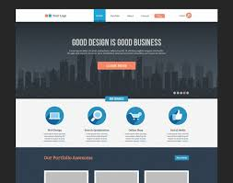 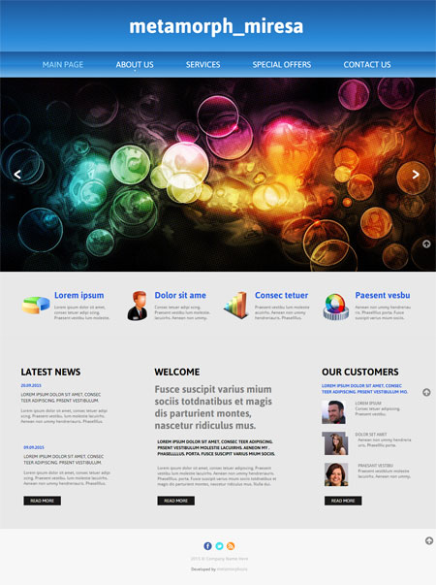

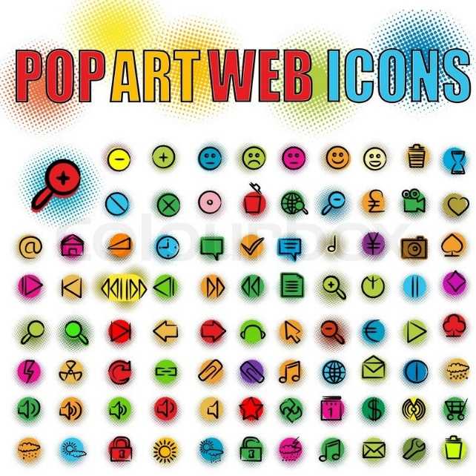

Recommended Layouts

